

Practices for Secure Software Report

Table of Contents
Practices for Secure Software Report 1
Document Revision History 3
Client 3
Instructions 3
Developer 4
1. Algorithm Cipher 4
2. Certificate Generation 4
3. Deploy Cipher 4
4. Secure Communications 4
5. Secondary Testing 4
6. Functional Testing 5
7. Summary 5
8. Industry Standard Best Practices 5
9. Resources 5

Document Revision History

Version | Date | Author | Comments
1.0 | 12/17/2023 | Laura Pittman

Client



Instructions

Submit this completed practices for secure software report. Replace the bracketed text with the relevant information. You must document your process for writing secure communications and refactoring code that complies with software security testing protocols.

- Respond to the steps outlined below and include your findings.
- Respond using your own words. You may also choose to include images or supporting materials. If you include them, make certain to insert them in all the relevant locations in the document.
- Refer to the Project Two Guidelines and Rubric for more detailed instructions about each section of the template.

Developer
Laura Pittman

Algorithm Cipher

The client wants to modernize their operations, and as a crucial part of the success of their custom software, they also want to use the most current and effective software security. The value of secure communications to Artemis Financial is immense as they will often handle customer and employee personal information such as Social Security Numbers (SSN), bank account and routing numbers, financial information, etc. that must always be kept secure to give users peace of mind. Considering Artemis Financial deals with financial plans for their customers and there was no mention of the company being based only in the United States it is safe to assume they do make international transactions. With this there are some government restrictions about secure communications that must be taken into consideration regarding the financial aspect of the business which simply ensure the company follows the current guidelines and regulations and legal action is not required for any reason. For the given scenario the recommended encryption algorithm cipher that avoids collisions is SHA-256. The SHA-256 algorithm is one type of the Secure Hash Algorithm 2 (SHA-2) that was created by the National Security Agency in 2001 and is even required in some US government agencies to protect sensitive information as it is one of the most secure hashing functions. This is due to the fact that hashing allows data to be mapped to data of a fixed size, in this case a 256-bit string in which the data will be modified to be completely unreadable without the key which enables the verification of the integrity of secure files, makes it nearly impossible to restore the initial data, and greatly lowers the likelihood of a collision, or what happens when two messages have the same hash value (N-able, 2019).

Certificate Generation

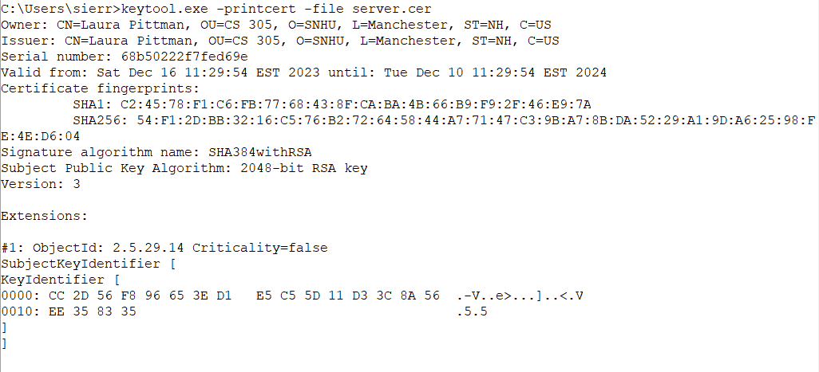

Deploy Cipher

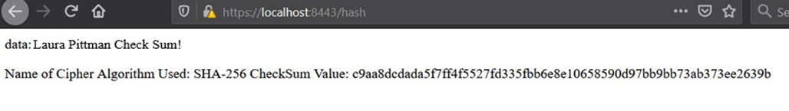

Secure Communications

The triangle next to the lock is due to the certificate being self-signed.
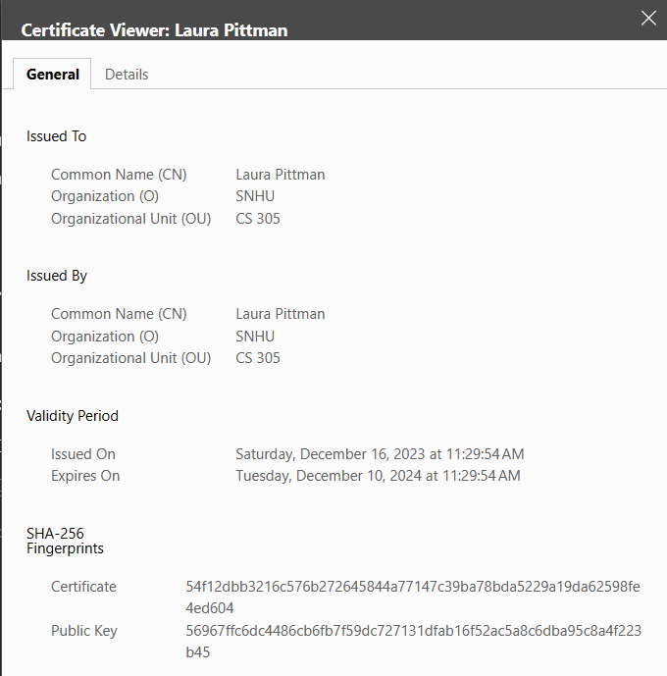

Secondary Testing

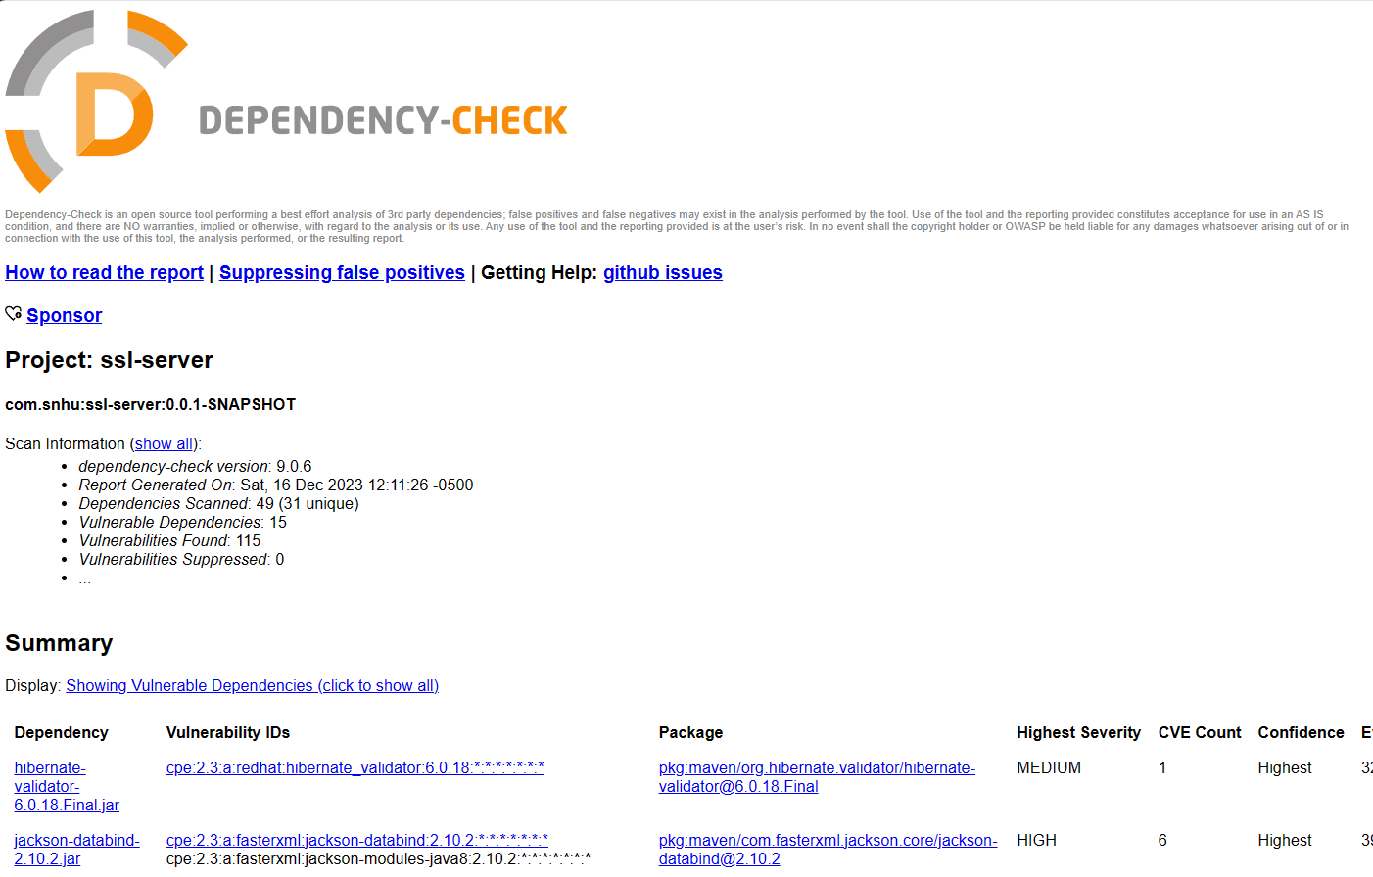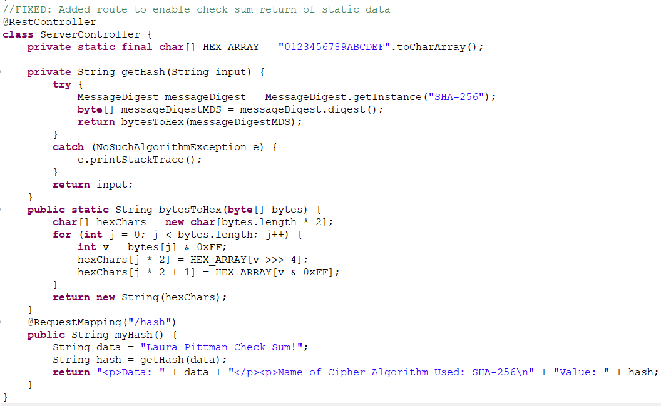

Functional Testing

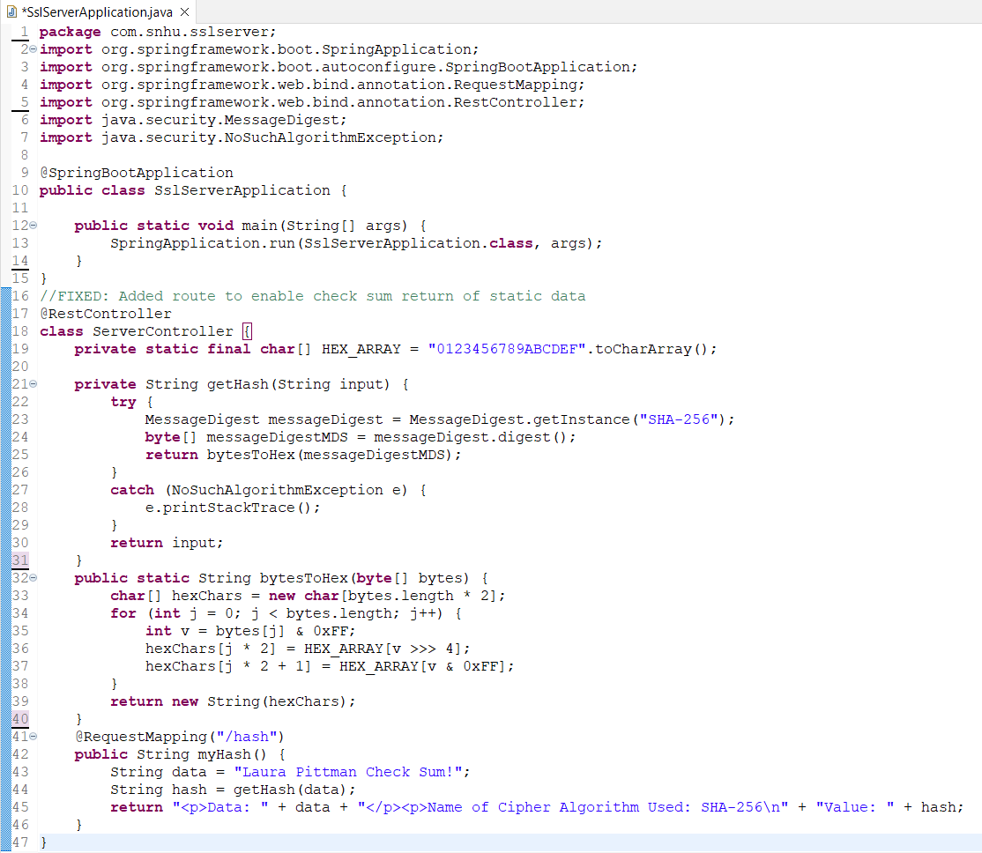I ensured the application.properties file was updated and accurate. 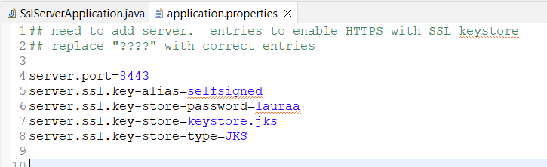I also updated the Dependency check to run the most current version to ensure the most accurate results were produced. 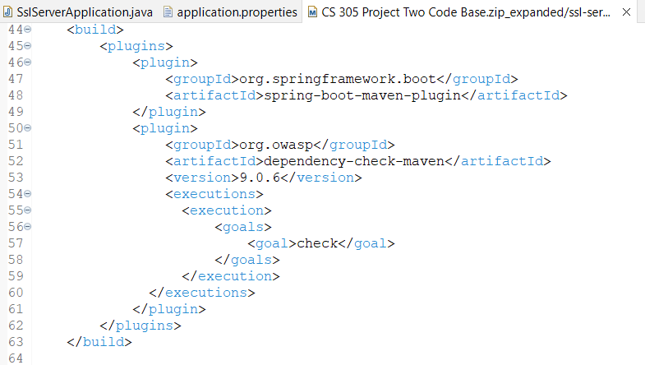

Summary

When refactoring the code, I made sure to refer to the Vulnerability Assessment Process Flow Diagram to confirm that all seven areas were attended to, but most importantly that input validation, APIs, cryptography, code quality, and encapsulation were sufficiently and properly addressed and implemented. Input Validation ensured all user input is secure and accurately represented, while Encapsulation and Code Quality ensured the code itself is structurally secure and protected from unauthorized access. Cryptography allowed for secure data transfers to occur between all users from any area of the world. As Artemis Financial already has a RESTful web application programming interface (API), it was necessary to evaluate and improve it to ensure it was operating at the necessary standard. Overall, the code has been refactored to comply with security testing protocols by addressing various security vulnerabilities through secondary static testing and debugging to ensure it will run the most current version of all associated libraries and plug-ins.

Industry Standard Best Practices

Industry standard best practices for secure coding were applied by updating multiple libraries and plug-ins to run the most current versions, implementing a strong encryption algorithm with a key length of at least 256 bits, employing a self-signed certificate to allow a secure HTTPS connection, and applying input validation. These practices combined allow for the software application to mitigate against known security vulnerabilities, and for its current security to be maintained. Additionally, applying industry standard best practices for secure coding is essential to the company’s overall wellbeing as consumers can rest assured knowing their sensitive data is protected from malicious attacks and it adds another layer of credibility to the company itself.

Resources

N-able. (2019, September 12). SHA-256 Algorithm Overview. https://www.n-able.com/blog/sha-256-encryption

